Enhanced Search Card Rollout: Communication Templates
This document contains draft communications to facilitate the rollout of the Enhanced Search Card experience.

Template 1: Internal Organizational Update
Target Audience: Internal staff, support teams, and stakeholders.
Goal: Explain the "why" behind the change and provide the rollout timeline.
Subject: Release Announcement: Upcoming Modernization of Our Provider Search Experience
Dear Team,
To ensure we are providing the most efficient path to care for our members, we will soon be upgrading the search card experience on our platform. This change is an intentional move to modernize our site and streamline how members find and select care providers.

Why are we making this change?
The enhanced search cards create a cleaner, more intuitive experience by presenting information in a way that is easier for members to scan and navigate. The design is more closely aligned with the consumer-grade experiences people have come to expect in everyday digital interactions. By bringing that same level of simplicity and clarity into healthcare search, we can better meet member expectations and make decision-making easier.
Key Optimizations you will notice in the example below:
- More intuitive layout: Aligned to 2026 design best practices, making information easier to scan and understand.
- Get important answers at a glance: Critical details like phone numbers and hours of operation are now prioritized in the header, ensuring members can spot them immediately.
- Promote key information while reducing visual noise: Simplified, customizable layouts show up to four attributes and automatically hide empty fields for a cleaner search experience.
- Take action more easily: The layout of critical hyperlinks and buttons are optimized to promote the most frequent member actions, including call to book, book now, select PCP, and compare providers.
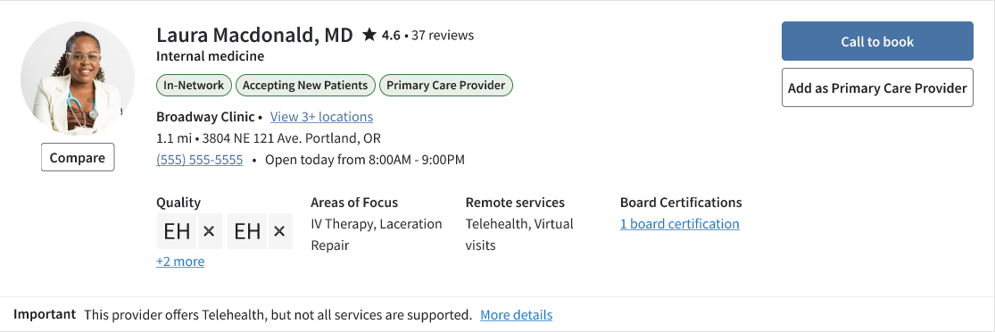
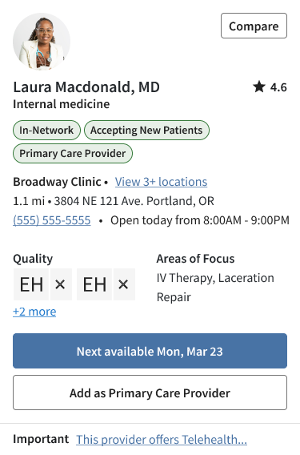

Timeline
- UAT Launch: The new experience will be available in our User Acceptance Testing (UAT) environment starting March 31st.
- Preview Period: We will have a 4 week preview window in UAT to allow time for feedback from customers and ensure everything is working as expected.
- Production: The upgrade will be "Auto-On" in production following the preview period.

Next Steps
We will provide detailed FAQs and technical documentation as we approach the UAT date. Please reach out if you have specific questions regarding how this impacts your department.
Best regards,
[Your Name]
[Your Title]

Template 2: Member-Facing Announcement
Target Audience: Members/Patients.
Goal: Build excitement for the refreshed UI and explain the benefits.
Subject: A New and Improved Way to Find Care
Dear Member,
Finding the right doctor is about to get easier.
In the coming weeks, you’ll see a refreshed look when searching for providers and facilities on our portal. The redesigned search results make it easier to make informed healthcare decisions with less effort.

What’s New?
- Key Details at a Glance: We’ve moved the most important information, like phone numbers and office hours, to the top of each results card. Bold badges make it easy to quickly identify the right provider for your needs.
- Enhanced Clarity: We’ve cleaned up our search results to show you only the most relevant details. By automatically hiding empty fields, we’ve made it easier for you to focus on the information that matters most.
- Take Action Faster: It’s now easier than ever to get the care you need. We’ve made the most popular actions—like calling to book, scheduling online, or selecting a new Primary Care Provider—easier to find.

Why the change?
Your healthcare journey should be simple. These updates are part of our ongoing commitment to providing a modern, high-quality digital experience that helps you get the care you need when you need it.
Thank you for being a member.
Sincerely,
[Health Plan Name]

